Prometheus and Grafana
- Install Prometheus on a server and configure prometheus.yml.
Step 1: Update installed packages
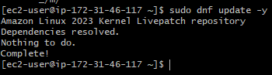
Install the required utilities:
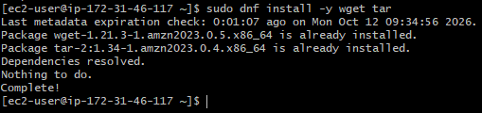

Step 2: Create the Prometheus user and directories
- Create a dedicated service account:
- Create directories for the configuration, data, and console files:
- Set ownership:
- /etc/prometheus stores the configuration.
- /var/lib/prometheus stores collected metrics.
- The prometheus user runs the monitoring service.
If the user already exists, useradd may report that the account exists; continue by checking that it is configured correctly.

Step 3: Download Prometheus
The official Prometheus download page lists version 3.15.0 as a release available for Linux AMD64.
Check EC2 CPU architecture:

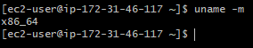
• x86_64 means use the AMD64 package below.
Change directory to tmp
Install Prometheus using wget url and extract the archieve.
Now open the extracted folder and check the list of files.
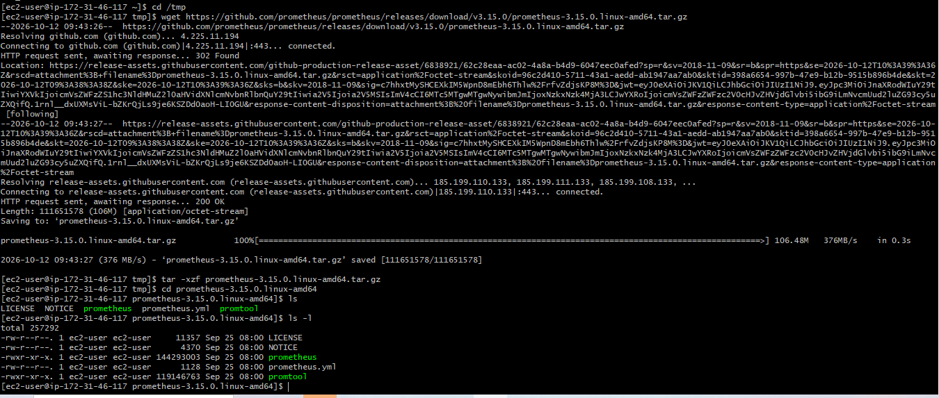

Step 4: Install the Prometheus binaries

Also verify the installation

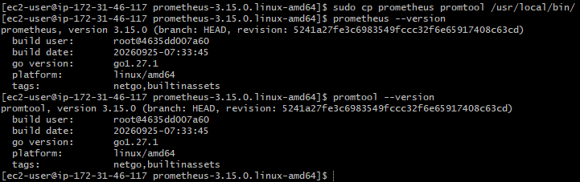

Step 5: Create the configuration and data directories
Now copy the configuration file and verify:

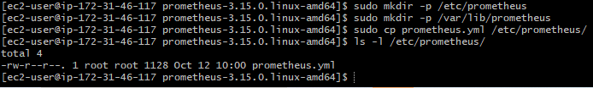

Step 6: Configure prometheus.yml

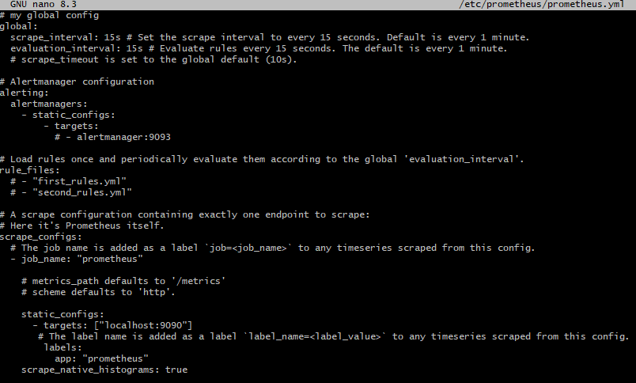
All the configurations are correct, so save and exit the editor. In Nano, press Ctrl+O, Enter, then Ctrl+X.
Validate the configuration:

2. Install and configure Node Exporter for system monitoring.

Step 1: Download and install Node Exporter

Change directory to tmp to download the Node Exporter

Using wget url, install Node Exporter. Extract the archieve.

Copy the executables and verify the installation.

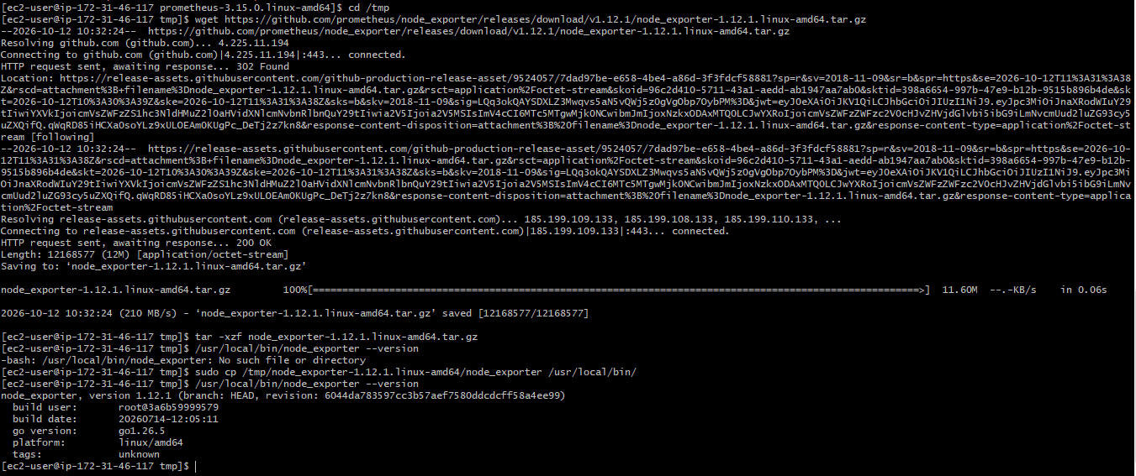

Step 2: Create a Node Exporter user
Create a dedicated service account:

Step 3: Create a systemd service
Create the service file:
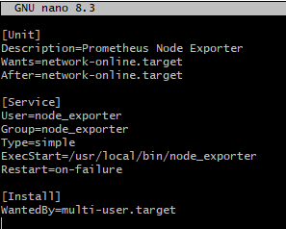
Save with Ctrl + O, press Enter, and exit with Ctrl + X.
Reload system, enable service and start it.
Now check the status of the service:
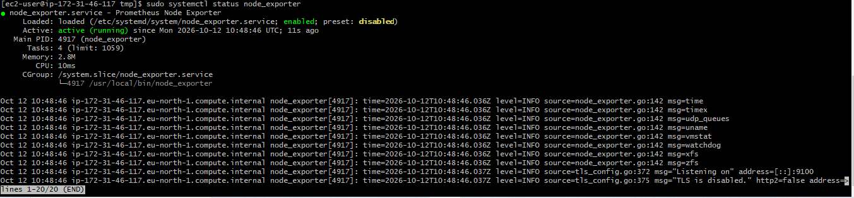

Step 4: Test Node Exporter
Check whether port 9100 is listening:
Test the metrics endpoint locally:

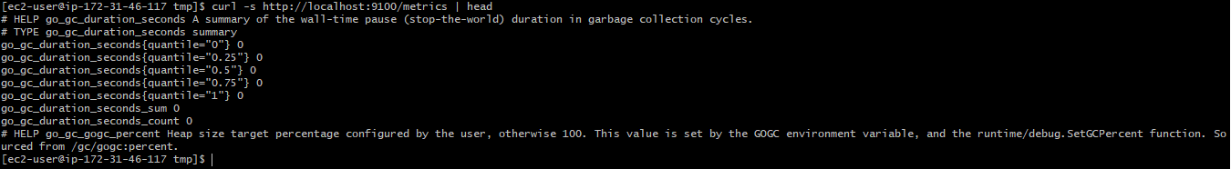
Node Exporter exposes system metrics on port 9100 by default.

Step 5: Configure Prometheus to collect Node Exporter metrics
Now connect Node Exporter to the Prometheus server you installed earlier.
Open the existing configuration and add second job with name Node exporter.

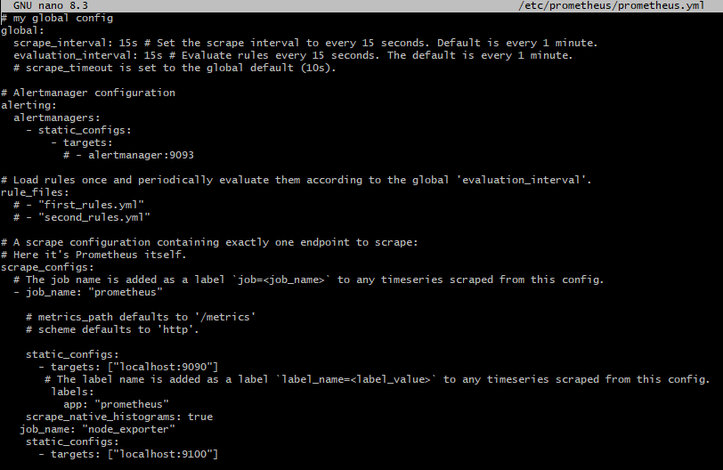

The two jobs now monitor:
Job | Port | Purpose
prometheus | 9090 | Prometheus application metrics
node_exporter | 9100 | Linux system metrics
Because both services run on the same EC2 instance, you do not need to expose port 9100 publicly.

Step 6: Validate and restart Prometheus
Validate the updated YAML:
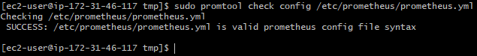

Reload Prometheus, enable and start it.

Then check the status of prometheus.

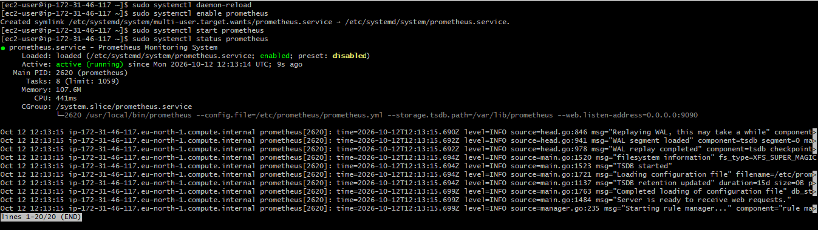

Step 7: Verify Prometheus and Node Exporter
Check Prometheus readiness:

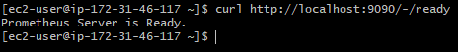
Check Node Exporter:
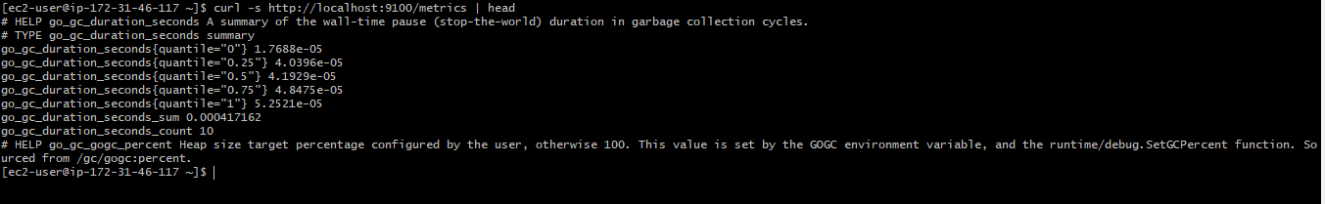
Finally, open this URL in browser, replacing the placeholder with your EC2 public IP:
http://YOUR-EC2-PUBLIC-IP:9090/targets
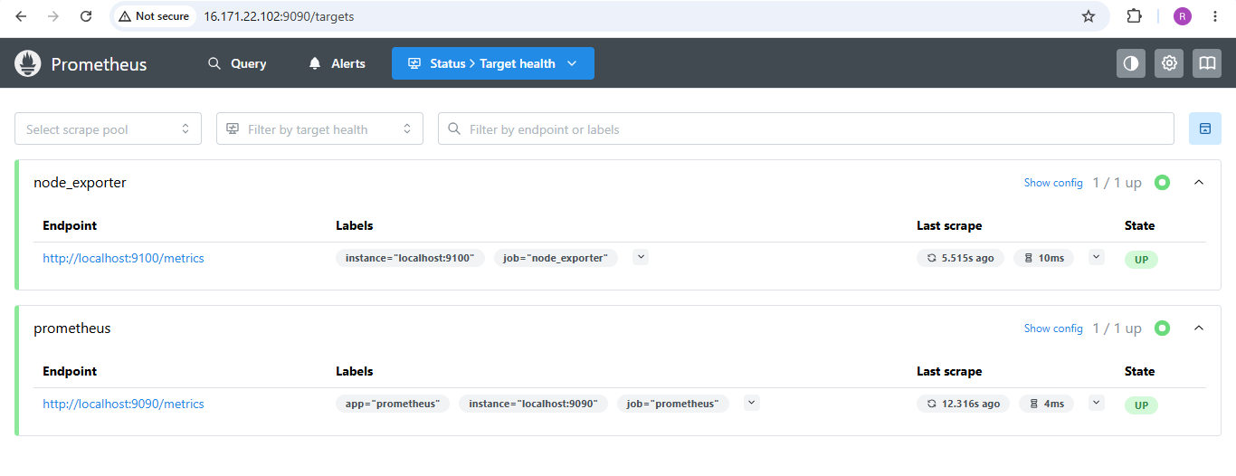

3. Set up SNMP Exporter to monitor network devices.

Step 1: Download SNMP Exporter

Change directory to tmp

Install SNMP using wget url, extract it, enter the directory and verify it.

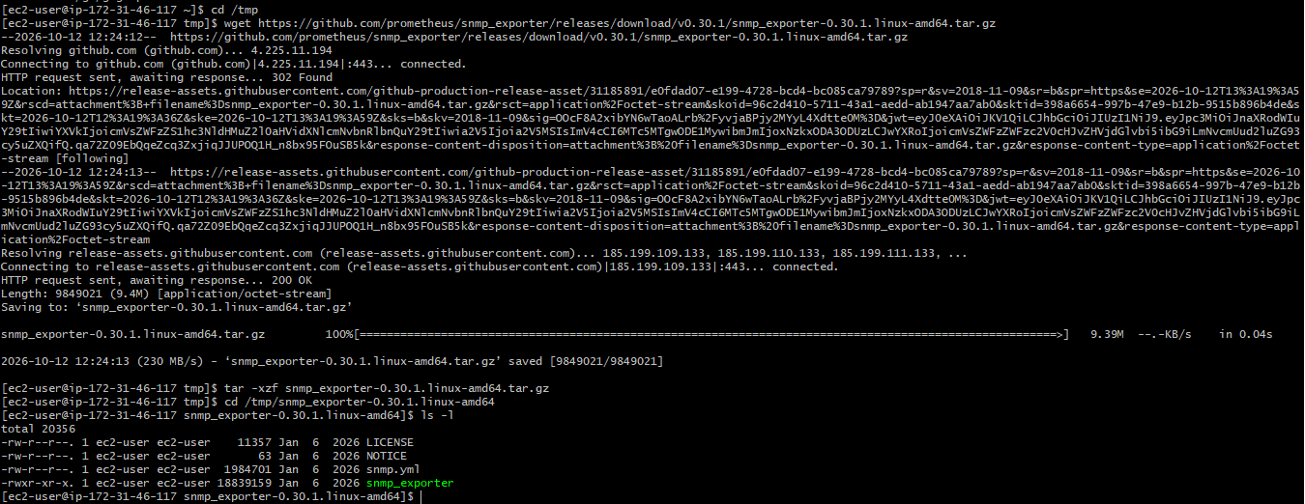

Step 2: Install the binary and configuration
- Copy the executable
- Create a configuration directory
- Copy the default SNMP configuration and verify it.
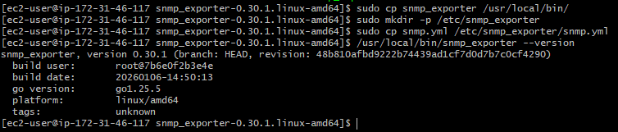

Step 3: Create a system user and set permissions

Step 4: Create a systemd service

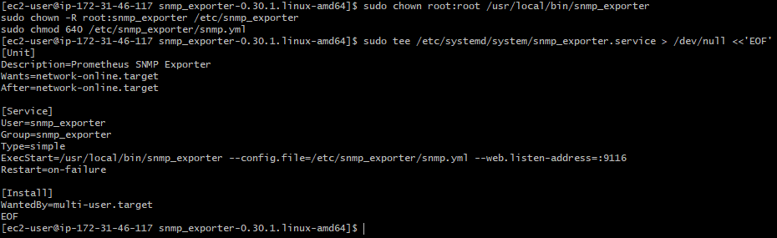
Enable and start the service:
Check the status:
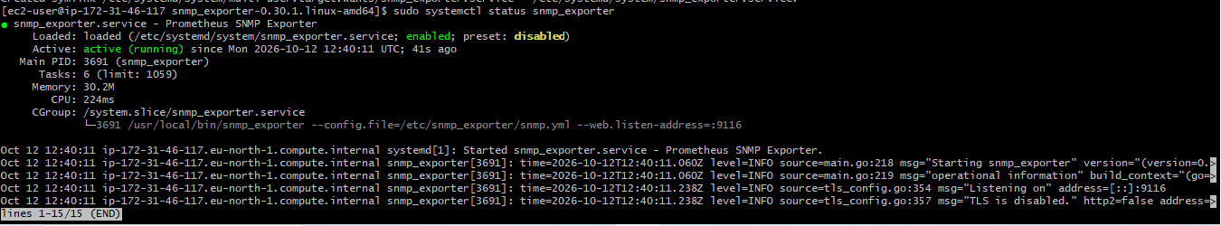

Step 5: Verify port 9116
Check its HTTP endpoint:

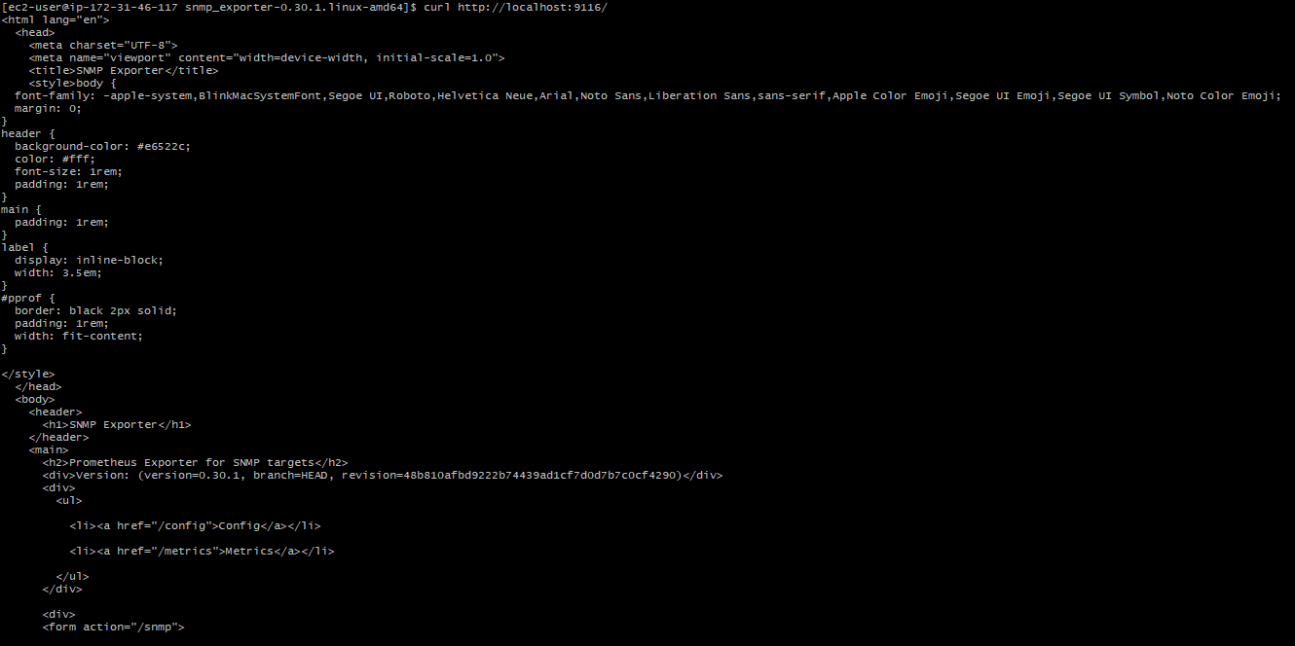

Step 6: Test SNMP collection
Check authentication profiles and modules in existing configuration:
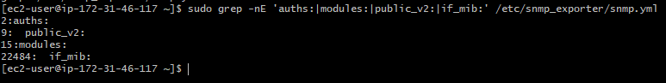

Test SNMP Exporter against your server
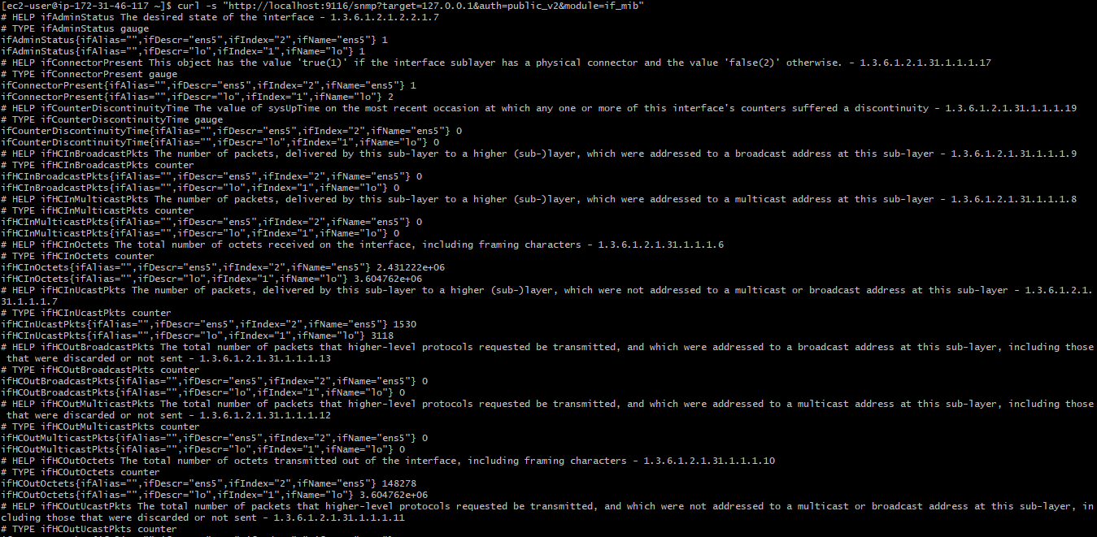
After the exporter test succeeds, add this job under scrape_configs: in /etc/prometheus/prometheus.yml, preserving your existing jobs:
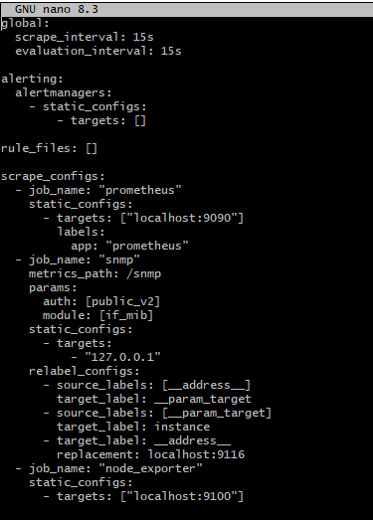
Validate the configuration:
Restart Prometheus service and check the status:
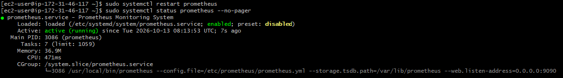
Now access SNMP in browser:
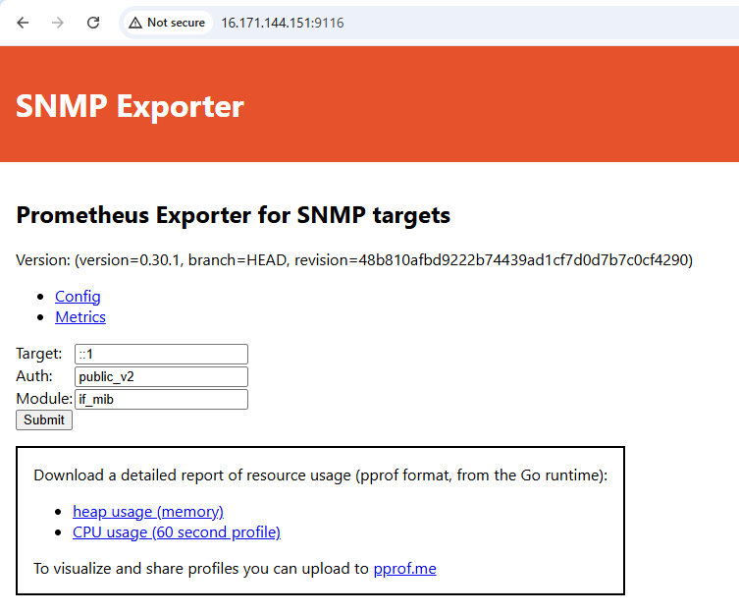
4. Set up Prometheus to run as a systemd service for automatic startup.

Step 1: Verify the Prometheus installation

Step 2: Create the Prometheus systemd service

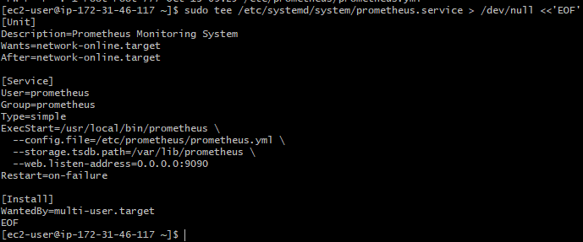

This creates systemd service file.

Step 3: Set permissions
Ensure the Prometheus user exists and can access its configuration and storage:
Ensure the Prometheus executable is accessible:

Step 4: Enable and start Prometheus
Reload systemd so it detects the new service:
Enable automatic startup and start Prometheus now and also check the status.
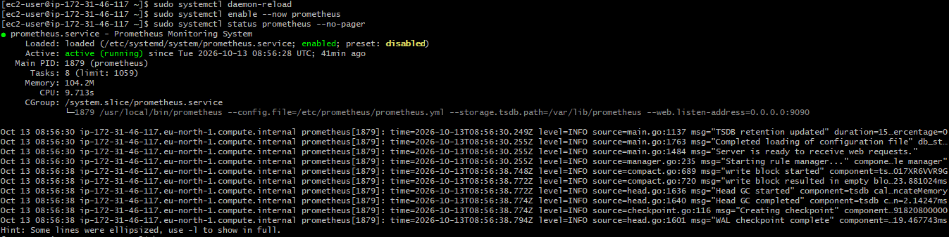

Step 5: Verify Prometheus is running
Check the local HTTP endpoint:

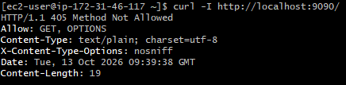
Check that systemd has enabled automatic startup:

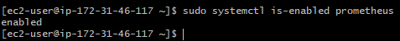

Step 6: Access Prometheus in your browser

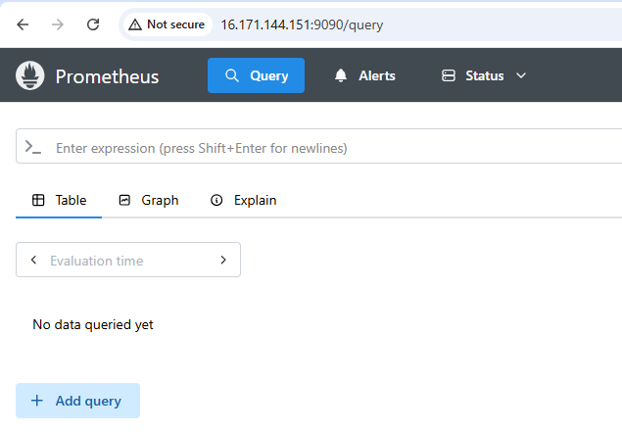
5. Install Alertmanager and configure an email alert.

Step 1: Download and install Alertmanager

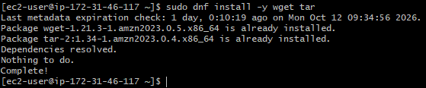
Download Alertmanager:
Change directory to tmp and download Alertmanager using wget url
Then extract it.
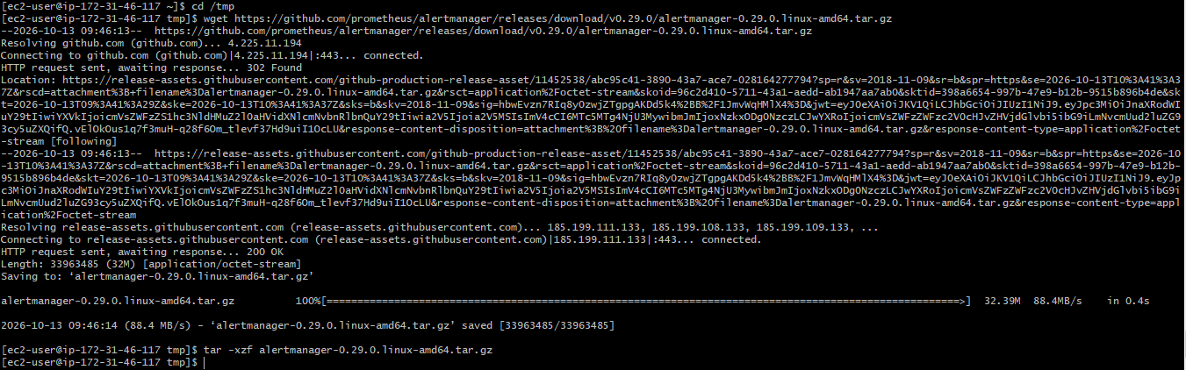
Install the binaries:
Verify the installation:
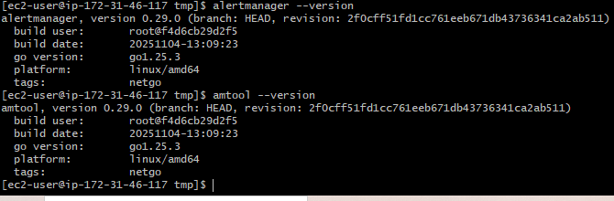

Step 2: Create the Alertmanager user and directories
Create the configuration and data directories and set ownership:

Step 3: Configure email notifications
You need a Gmail address and a Google App Password. An ordinary Gmail account password will not work for this setup.
- Enable 2-Step Verification on your Google account.
- Create an App Password in your Google Account security settings.
- Keep the generated password private.

Enabled 2-step verification for Google account:
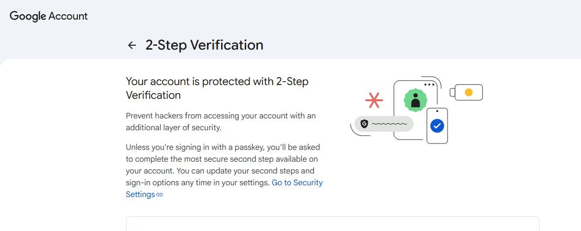

Created App password for Prometheus. yhav fosh irqe kvek

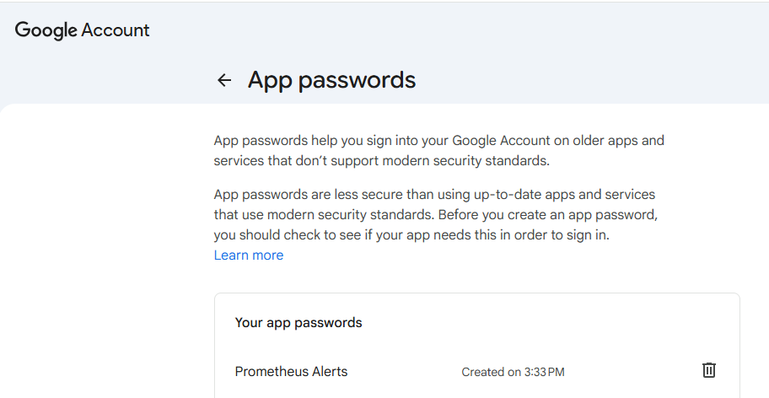
Create the configuration file:
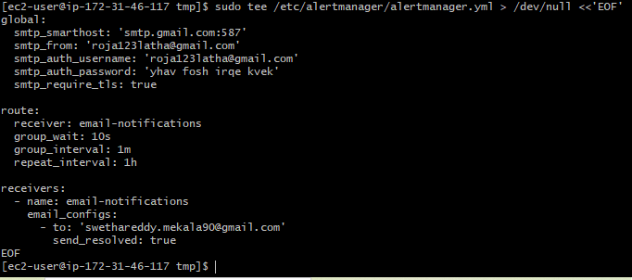
Restrict access to the configuration because it contains credentials:

Step 4: Create the Alertmanager systemd service
Create the service file:
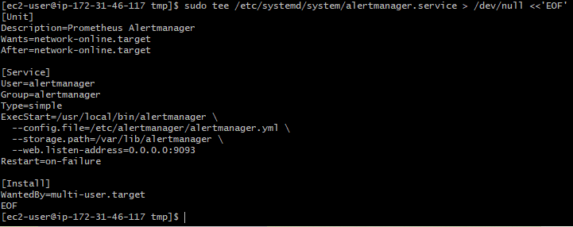
Reload systemd and start the service and check the status of systemd:
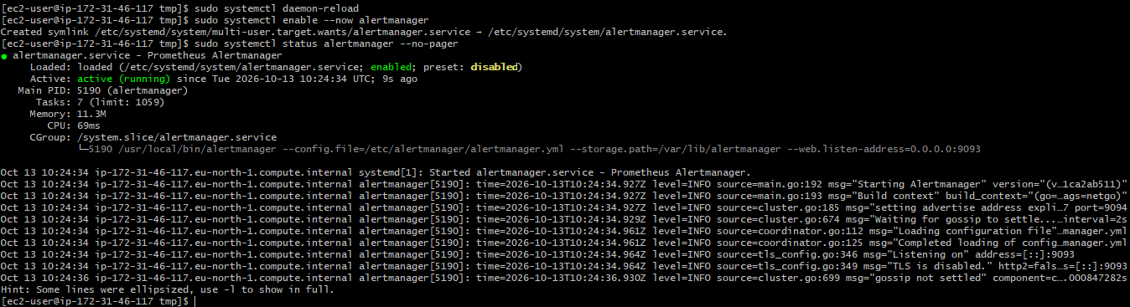
Validate the configuration:
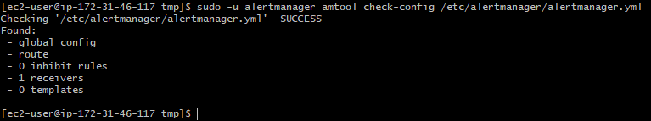

Step 5: Connect Prometheus to Alertmanager
Open Prometheus configuration and add target for 9093 and rule_files:
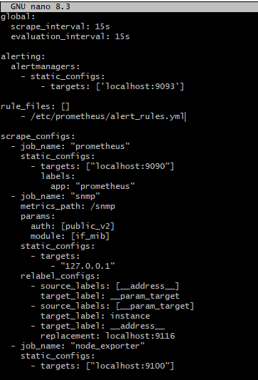

Step 6: Create an alert rule
This will send an alert if a monitored target is down.
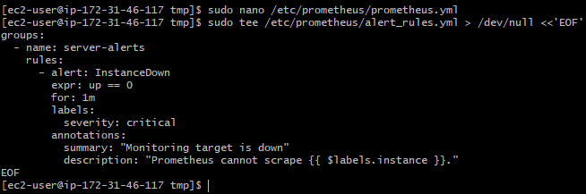
Set permissions for Prometheus to read the rule:
Validate the Prometheus configuration and rule file:
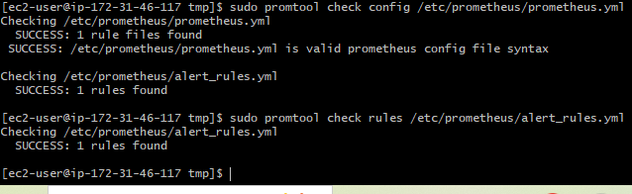
As both checks succeed, now restart Prometheus:
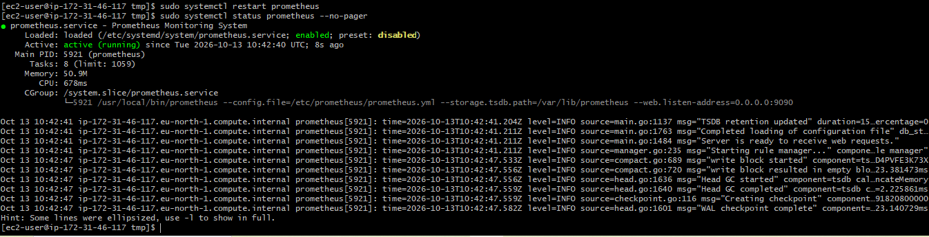

Step 7: Verify in your browser
Prometheus dashboard:
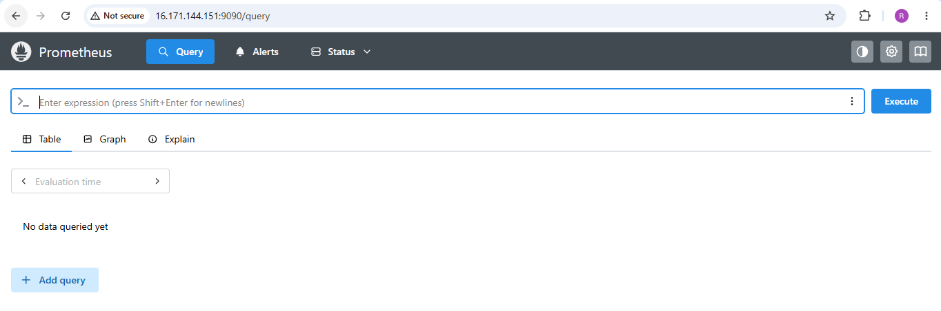
Alertmanager Dashboard:
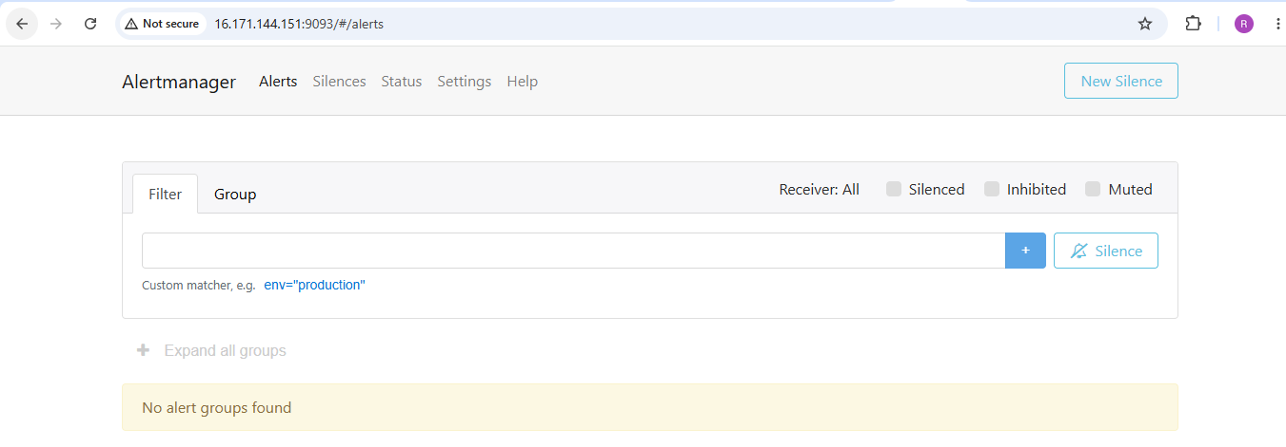

Step 8: Test email delivery

Received alert on Alertmanager:

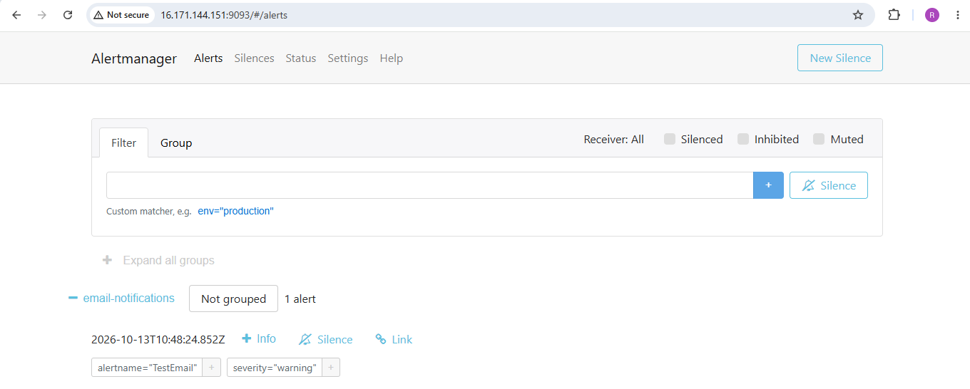

Alert received on Receivers email:

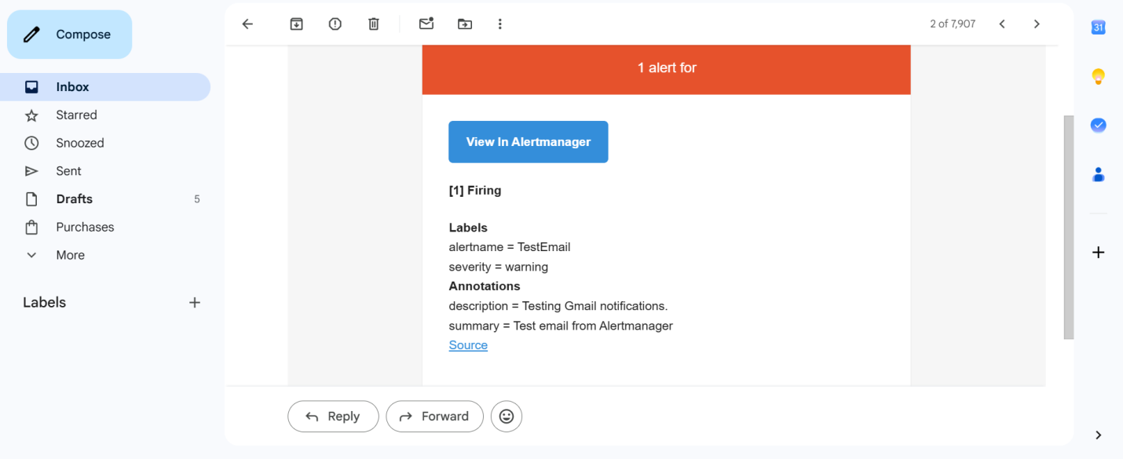

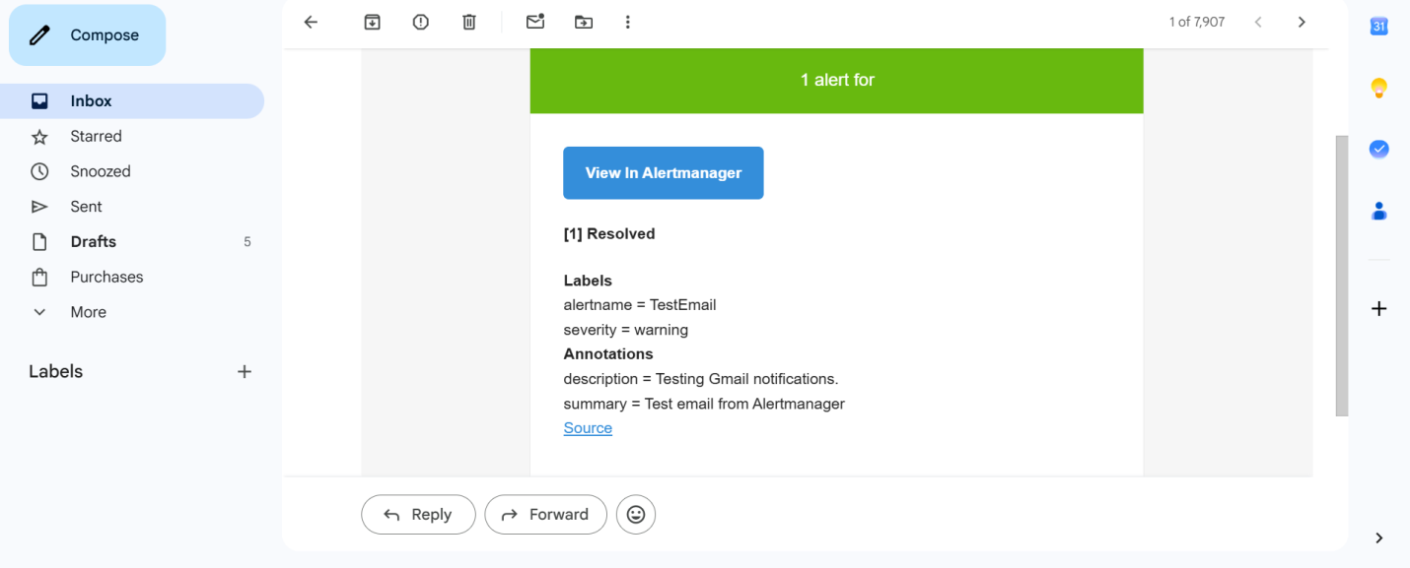
6. Install Grafana and add Prometheus as a data source.

Step 1: Install Grafana
Add the official Grafana repository:
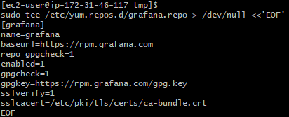
Install Grafana:
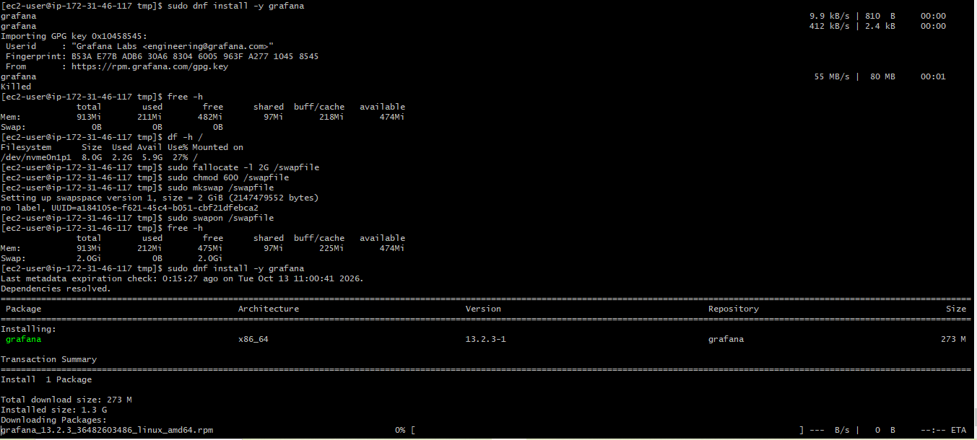
This downloads and installs Grafana using the official RPM repository.

Step 2: Start Grafana and enable automatic startup

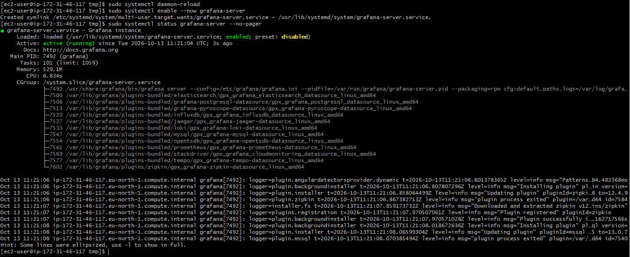

Step 3: Open Grafana in your browser
Log in with the default credentials:
- Username: admin
- Password: admin
Grafana will prompt to change the password, change it and login.

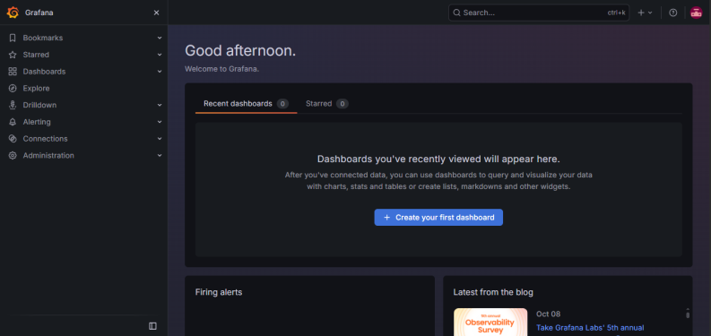

Step 4: Add Prometheus as a data source
1. Open Data sources
In Grafana, navigate to Connections → Data sources → Add data source.

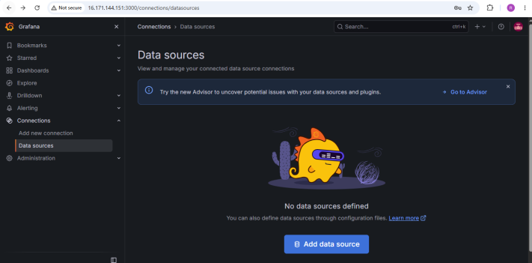
2. Select Prometheus
In the search box, type Prometheus and select it.
In the Prometheus server URL field, enter http://localhost:9090.
Leave the other settings at their defaults.
Click Save & test.

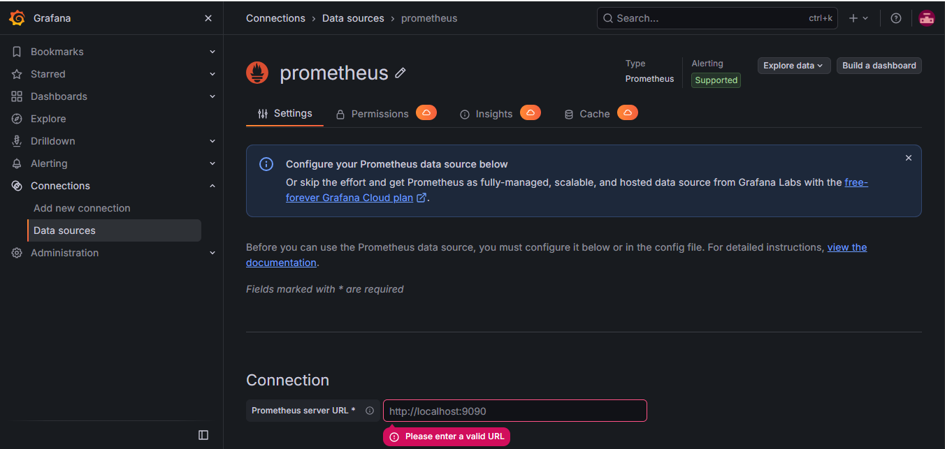
3. Enter the Prometheus URL
If Grafana and Prometheus are installed on the same EC2 instance, enter:
http://localhost:9090
Leave other settings at their defaults, then click Save & test. Grafana should confirm that the data source is working.

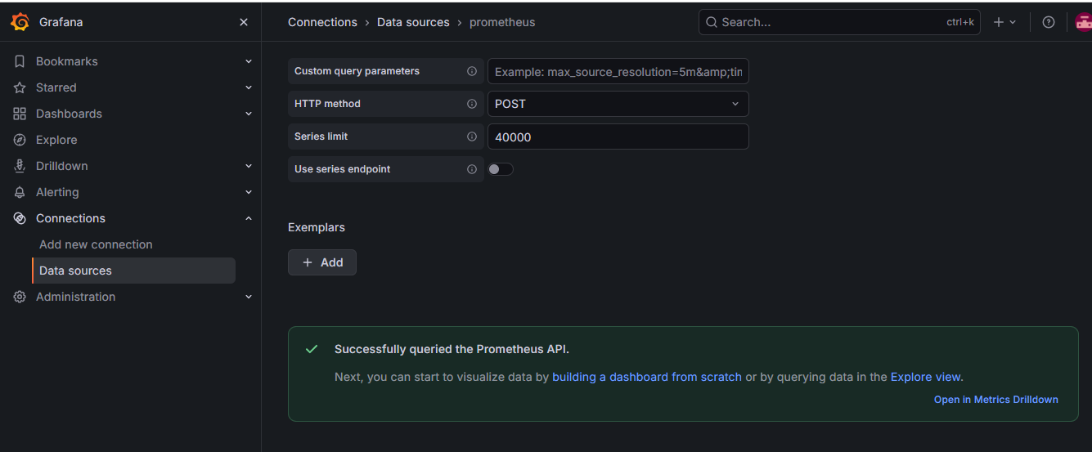

Step 5: Verify the installation

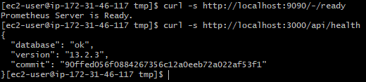

Step 6: Verify the data source
In Grafana, go to Explore, select Prometheus data source, and run:
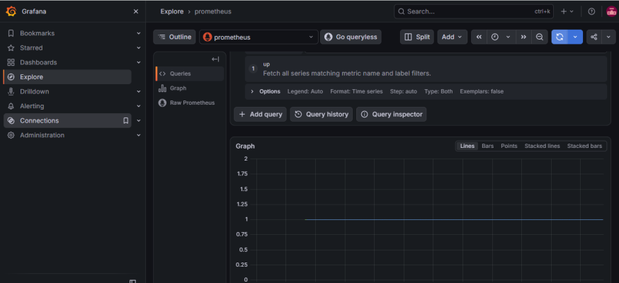

Step 7: Create a dashboard
- Go to Dashboards → New dashboard.
- Click Add visualization.
- Select the Prometheus data source.
- Enter the query up.
- Select Stat or Time series.
- Click Apply, then save the dashboard as EC2 Monitoring Dashboard.
Below is the Grafana Time Series Visualization for last 15 min

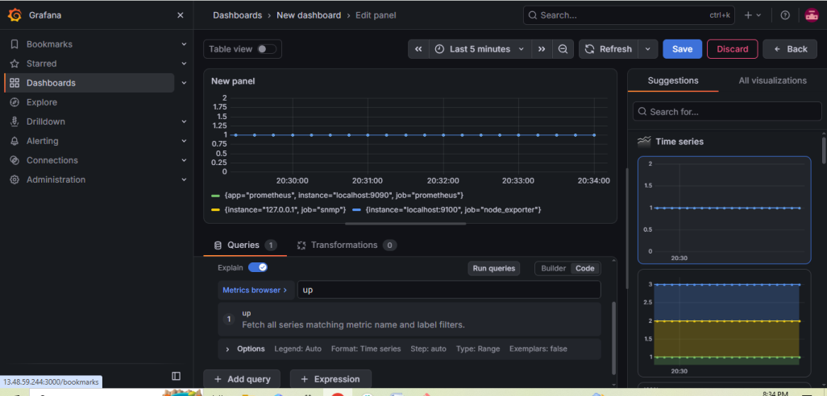

Below is the Grafana stat visualization

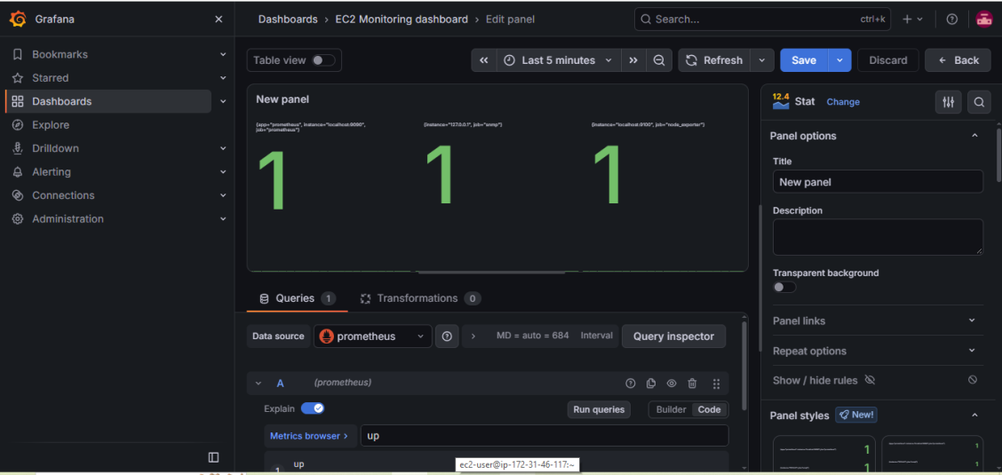
7. Configure Prometheus for service discovery of dynamic targets.

Step 1: Create a dynamic targets file
This file contains the target that Prometheus will discover. Later, we can add more targets without changing the Prometheus configuration.

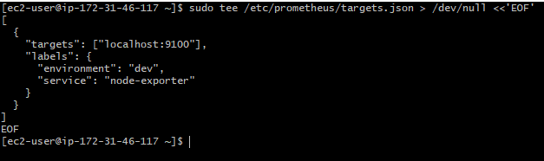
Set readable permissions:
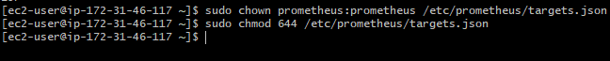

Step 2: Configure Prometheus
Open the configuration file and add the below job without changing other jobs:
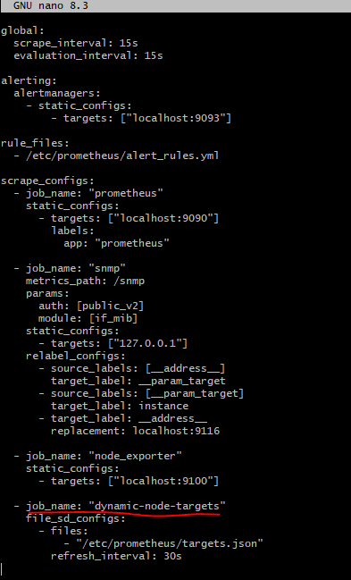
Save the file using Ctrl+O, press Enter, then Ctrl+X.

Step 3: Validate the configuration

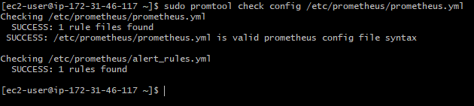

Step 4: Reload Prometheus

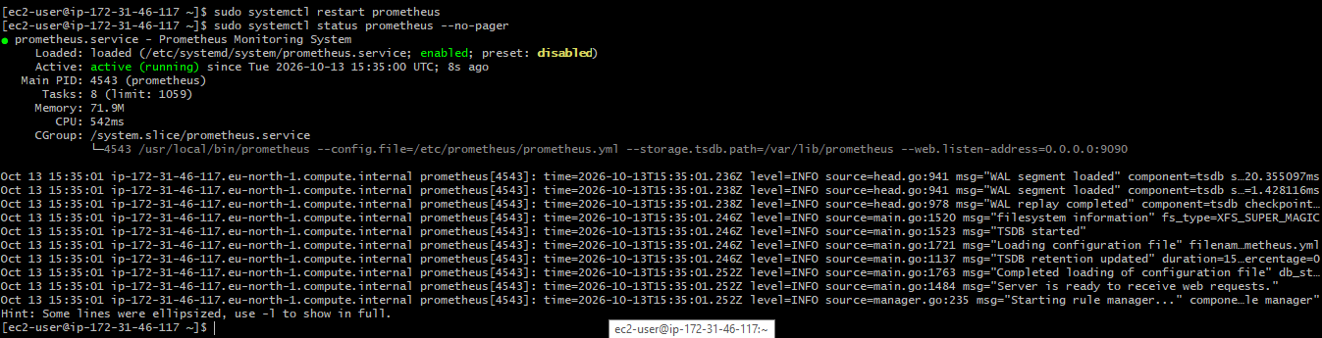

Step 5: Verify service discovery
Open this URL in your browser:
Find the job dynamic-node-targets. It should discover localhost:9100 and show as UP.

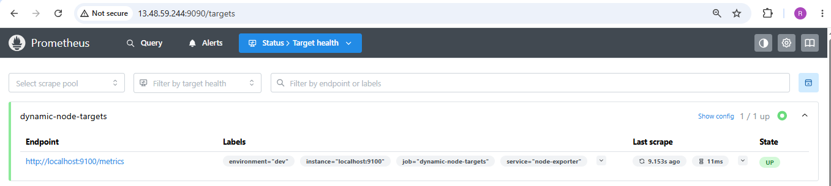
Test using the Prometheus query:

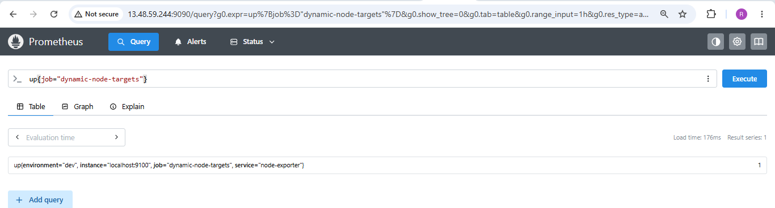

Step 6: Test that discovery is dynamic
Add a second target to the JSON file.

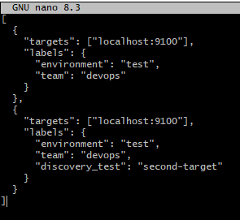
Save file using Ctrl+O, Enter, then Ctrl+X.
Save the file and wait approximately 30 seconds. Refresh the Prometheus Targets page. The second target should appear without restarting Prometheus.
Both entries intentionally use the same endpoint to demonstrate file discovery; they are not two separate servers.

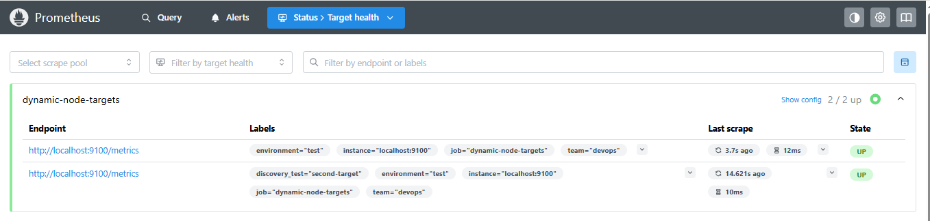

The dynamic-node-targets job appears in Prometheus, the target file is read successfully, and target changes are detected automatically.

8. Create alerting rules for monitoring disk space.

Step 1: Verify Node Exporter disk metrics
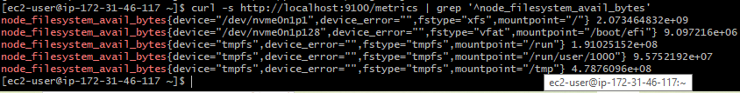
In above screenshot see metrics for mounted filesystems, including available disk space in bytes.
Check the filesystem mount points:
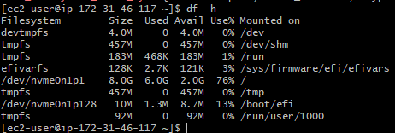

Step 2: Create the disk alert rules file
Create or edit the rules file:
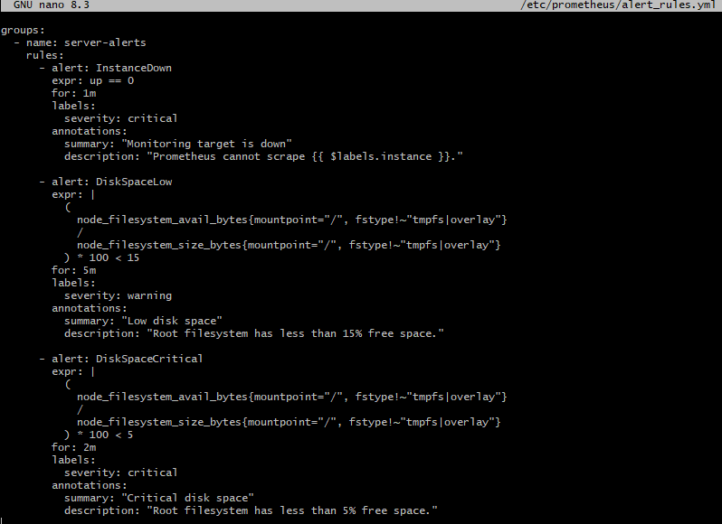
Save file using Ctrl+O, Enter, then Ctrl+X.

Step 3: Validate the rules

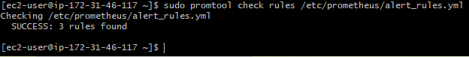
Then validate the full configuration:
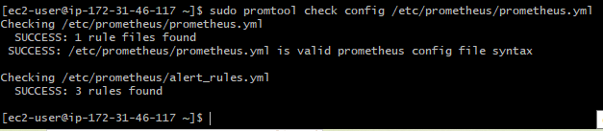

Step 4: Restart Prometheus
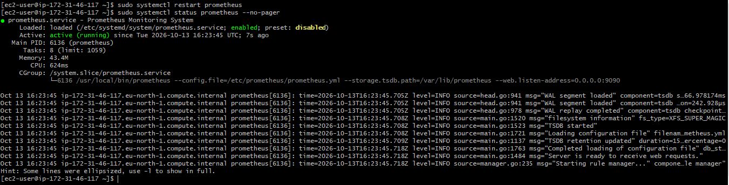

Step 5: Verify alerts in the browser

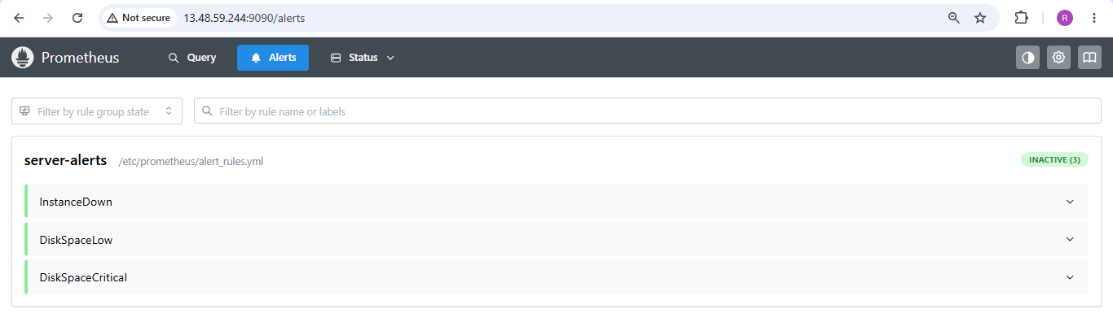
9. Create a custom Grafana dashboard using Prometheus metrics for specific insights.

Step 1 — Check Grafana on your EC2 instance

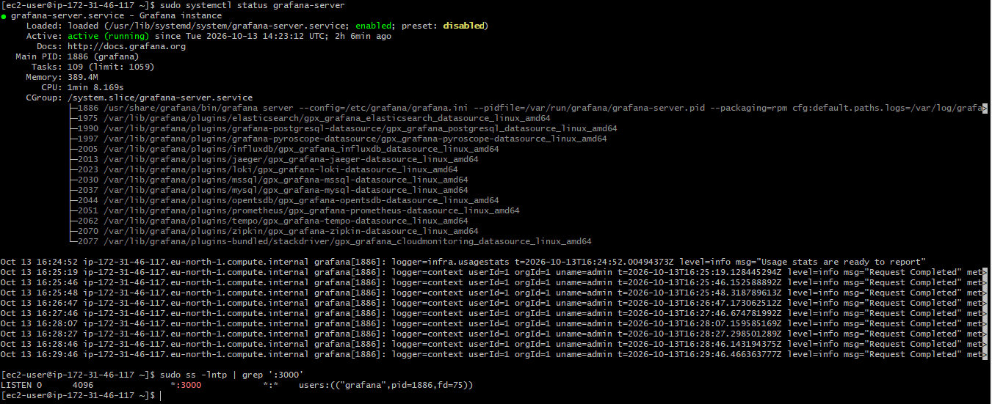

Step 2 — Create the custom dashboard
Go to Dashboards → New → New dashboard → Add visualization. Select Prometheus data source.
Create these six panels. For each one, enter its PromQL query in the query editor and select the recommended visualization.

Panel 1 — CPU Usage

Panel 2 — Memory Usage

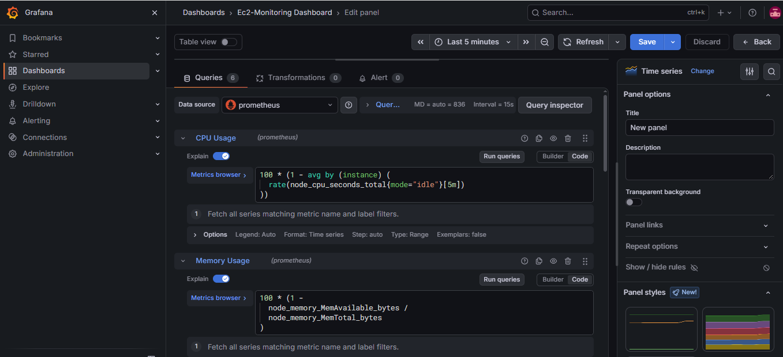

Panel 3 — Root Disk Usage

Panel 4 — Server Availability

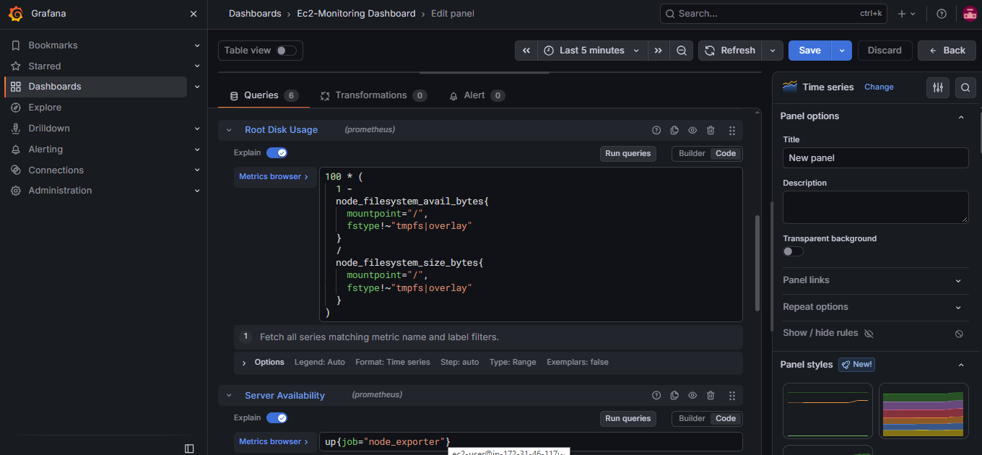

Panel 5 — Network Traffic

Panel 6 — System Load

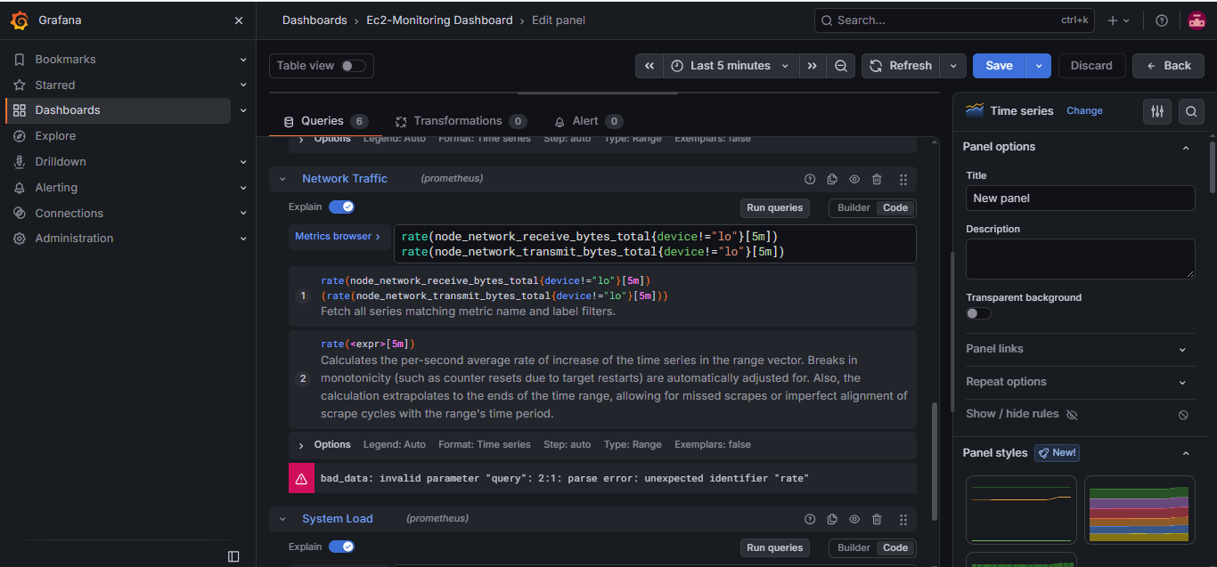
For each panel, click Apply to add it to the dashboard. When all six are present, save the dashboard as EC2 Monitoring Dashboard.

Step 4 — Test the dashboard data
Before troubleshooting Grafana, confirm that the metrics are available. On the EC2 instance:
Check the Node Exporter target in Prometheus in browser:
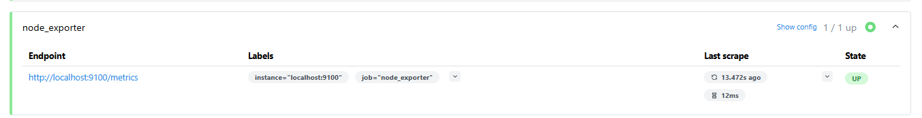
Grafana visualization for above 6 panels
